A000-ME-Mesopotamia-Seal-Cylinder-Hunter-Lion-Chariot-Agate-3000 BCE

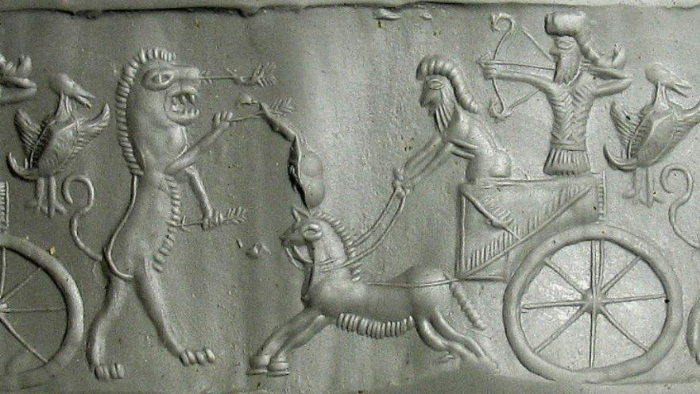

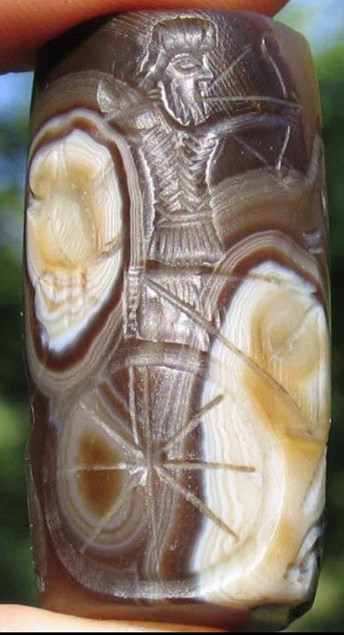

Formal Label: Mesopotamia-Seal-Cylinder-Hunter-Lion-Chariot-Onyx-3000 BCE

Accession Number:

Date or Time Horizon: 3000 BCE

Geographical Area:

Map:

GPS:

Cultural Affiliation:

Medium: Agate

Dimensions: H 44 mm

Weight:

Provenance: Old English Collection

References: